SWE20004 Technical Software Development Semester 1 2020

Assignment 1 report

Name: Dipesh Goyal Student ID:102558284

Lab class: Friday/12:30 Tutor: Srikanth Thudumu

Due Date: Wednesday 8th April 2020 at 11:59 pm

Date Submitted: Saturday, 4 April 2020

Assignment Title: 1

Program description

This program alters the original data before transmitting due to security reasons. The program only takes integers as input. It takes user input between 2-8 digit numbers and performs encoding and decoding depending on the number of digits. It then also decodes the encoded numbers and shows the original input entered by the user. The user has an extra option for extra protection encoding if they enter 8-digit number.

Inputs and Outputs
The inputs and outputs for this program are described in Table 1.

Table 1. Data dictionary:
Data to be stored | Sample data | Type of data | C++ type | Input method | In /  Out | Variable name
Input by user | 1234 | Integer:2-8  numbers | Integer | cin | in | number
Length of input | 4 | Integer: 1 number | Integer | to_string(number).length(); | in | length
Encoded data | 5555 | Integer:2-8  numbers | Integer | cout | out | calc
Input by user in array | 1 2 3 4 | Integer: length size | Integer array | For Loop and array | in | Int num[]
Encoded data in array | 5 5 5 5 | Integer: length size | Integer array | For loop and array | out | Int array[]

3. Algorithm
Program steps:
  - Prompt the user to enter the input.
  - Check range – if too small or too big return to a and display error.
  - Display number of digits inputted
  - Display encoded number based on digits
  - Display decoded number.
  - If the input number is 8 digits, ask for extra protection.
  - If user types no, then display normal encoded number and decoded number
  - If user types yes, then display extra protected encoded number and the decoded number
  - Exit the program

Encoding logic:

Start
For i= length; i >= 1; decrement i
calc = (num(i -1) + i) modulus 10
array[j] = calc
j increments
print calc
end for loop
end

Decoding logic:

Start
For i=0; i < arraylength; increment i
Array[i] = array[i] + 9 – i
Array[i] = array[i] modulus 10
end for loop
end

Source code:
- #include <iostream>
- using namespace std;

- // Function Prototypes
- void reverse_array(int array[], int length);
- void decode(int array[], int arraylength);

- int main()
- {
- //Variables
- int number = 0;
- int length = 0;
- int calc = 0;
- int j;

- //Do while loop for validation of input
- do
- {
- cout << "Enter The Number: \n"; //Prompt to enter input
- cin >> number;
- if (number < 10 || number > 99999999) // condition if input out of range
- {
- cout << "Not a valid input, re enter the number\n"; // display if out of range
- }
- } while (number < 10 || number > 99999999); //while condition

- length = to_string(number).length(); //convering the input into string to check no. of digits and storing in length
- int num[length]; // using the length for array size.
- cout << "Number contains " << length << " digits\n"; //Display how many digits in the input

- for (int i = length - 1; i >= 0; i--) // Loop to store the input entered into the array.
- {
- num[i] = number % 10;
- number /= 10;
- }
- int array[length]; // Second array initiliazation

- switch (length) // Switch statement based on the length of the input
- {
- case 2:
- cout << "The encoded number is "; //Encoded Number
- for (int i = length - 1; i >= 0; i--) // Backwards loop to to encode the input
- {
- cout << num[i];
- }
- reverse_array(num, length); // reversing the encoded array to decode
- cout << "\nThe decoded number is "; //Decoded Number
- for (int i = length - 1; i >= 0; i--) // Loop to display the decoded output
- {
- cout << num[i];
- }
- break;
- case 3:
- cout << "The encoded number is "; //Encoded Number
- for (int i = length - 1; i >= 0; i--) // Backwards loop to to encode the input
- {
- cout << num[i];
- }
- reverse_array(num, length); // reversing the encoded array to decode
- cout << "\nThe decoded number is "; //Decoded Number
- for (int i = length - 1; i >= 0; i--) // Loop to display the decoded output
- {
- cout << num[i];
- }
- break;
- case 4:
- reverse_array(num, length); // reversing the array
- cout << "The encoded number is "; //Encoded Number
- for (int i = length; i >= 1; i--)// Backwards loop to to encode the input
- {
- calc = (num[i - 1] + i) % 10; // the encoded logic from vid and stored in var calc
- array[j] = calc; // initializing array to calc and storing the values in array to be used later
- j++; //increments everytime the loop runs
- cout << calc; //prints encoded number
- }
- cout << "\nThe decoded number is "; //Decoded Number
- reverse_array(array, length); // reversing the array
- decode(array, length); //decode function passing the array that stored calc values
- reverse_array(array, length); // reversing the array
- for (int i = 0; i < length; i++) // loop to display decoded value
- {
- cout << array[i];
- }
- break;
- // the same process is used for rest of the cases till 7
- case 5:
- reverse_array(num, length);
- cout << "The encoded number is ";
- for (int i = length; i >= 1; i--)
- {
- calc = (num[i - 1] + i) % 10;
- array[j] = calc;
- j++;
- cout << calc;
- }
- cout << "\nThe decoded number is ";
- reverse_array(array, length);
- decode(array, length);
- reverse_array(array, length);
- for (int i = 0; i < length; i++)
- {
- cout << array[i];
- }
- break;
- case 6:
- reverse_array(num, length);
- cout << "The encoded number is ";
- for (int i = length; i >= 1; i--)
- {
- calc = (num[i - 1] + i) % 10;
- array[j] = calc;
- j++;
- cout << calc;
- }
- cout << "\nThe decoded number is ";
- reverse_array(array, length);
- decode(array, length);
- reverse_array(array, length);
- for (int i = 0; i < length; i++)
- {
- cout << array[i];
- }
- break;
- case 7:
- reverse_array(num, length);
- cout << "The encoded number is ";
- for (int i = length; i >= 1; i--)
- {
- calc = (num[i - 1] + i) % 10;
- array[j] = calc;
- j++;
- cout << calc;
- }
- cout << "\nThe decoded number is ";
- reverse_array(array, length);
- decode(array, length);
- reverse_array(array, length);
- for (int i = 0; i < length; i++)
- {
- cout << array[i];
- }
- break;
- case 8:
- string choice; // variable for extra protection
- cout << "Do you want to do a second level of encryption, enter yes or no? "; // prompt
- cin >> choice;
- if (choice == "yes")
- { //condition if yes to prompt
- reverse_array(num, length);
- cout << "The encoded number is ";
- for (int i = length; i >= 1; i--)
- {
- num[i - 1] = (num[i - 1] + i) % 10; //extra protection encoding
- }
- for (int i = 0; i < length; i++)
- {
- cout << num[i]; // prints encoded number
- }
- cout << "\nThe decoded number is ";
- decode(num, length); // decode the number
- reverse_array(num, length); // reverses the number
- for (int i = 0; i < length; i++)
- {
- cout << num[i]; // prints the decoded number
- }
- //WORKING!
- }
- else
- { // condition if no to the prompt
- reverse_array(num, length);
- cout << "The encoded number is ";
- for (int i = length; i >= 1; i--) // the normal 8 digit encoding if choice is no
- {
- calc = (num[i - 1] + i) % 10;
- array[j] = calc;
- j++;
- cout << calc;
- }
- cout << "\nThe decoded number is ";
- reverse_array(array, length);
- decode(array, length);
- reverse_array(array, length);
- for (int i = 0; i < length; i++)
- {
- cout << array[i];
- }
- break;
- }
- }
- return 0;
- }
- void decode(int array[], int arraylength) // function to decode logic taken from video
- {
- for (int i = 0; i < arraylength; i++)
- {
- array[i] += 9 - i;
- array[i] = array[i] % 10;
- }
- }
- void reverse_array(int array[], int length) // Function to reverse arrays that are passed
- {
- for (int i = 0; i < (length / 2); i++)
- {
- int temp = array[i];
- array[i] = array[(length - 1) - i];
- array[(length - 1) - i] = temp;
- }
- }

Screenshots showing working program (Show all possible outcome):
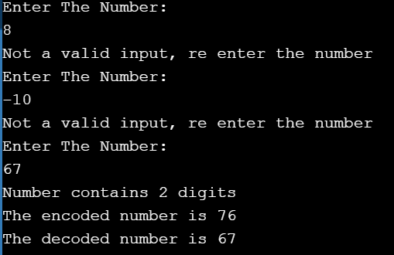

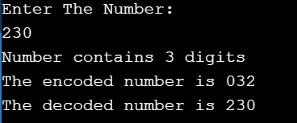
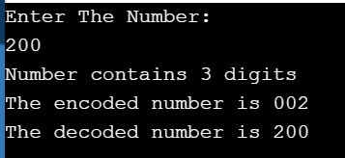
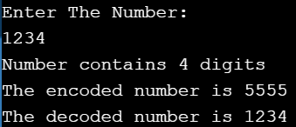
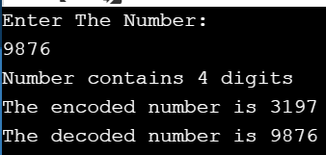
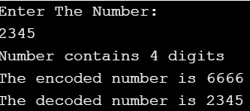
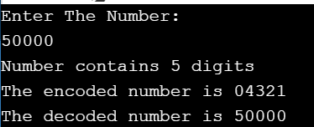
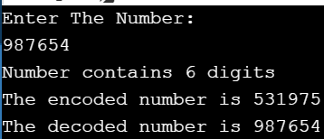
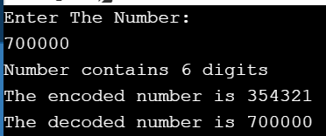
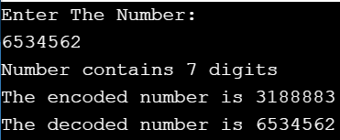
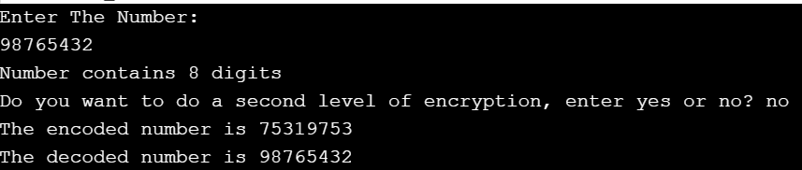

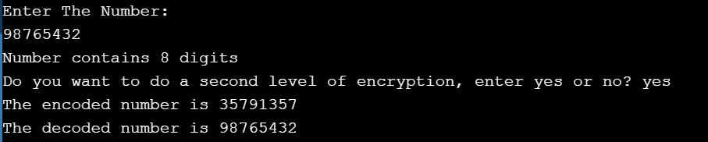
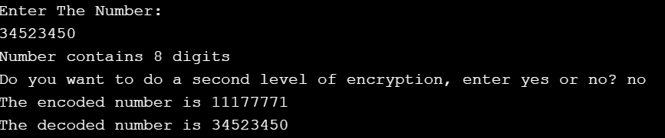
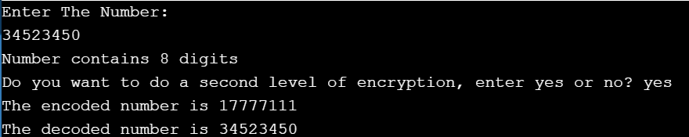

Task 2.11

Program description
This program calculates the voltage gain of an amplifier given the frequency and the stage of the amplifier. The cmath library is used to do the calculations in this program.

Source Code
- #include <iostream>
- #include <cmath>

- using namespace std;

- int main()
- {
- double x,y,voltage=0; // Variable Decalaration
- int stage = 0; // variable initialization
- cout<<"Enter the frequency: \n"; // User Prompts
- cin>> x; //storing frequency in variable x
- cout<<"Enter the stage of the amplifier: \n";
- cin>> stage; //storing stage in variable stage
- voltage = pow((275 / sqrt(pow(23,2) + 0.5 * pow(x,2))),stage); //Calculation
- cout<< "At a frequency of " << x <<" hertz, the voltage gain is " <<voltage; //Output
- return 0;
- }

Screenshots showing working program
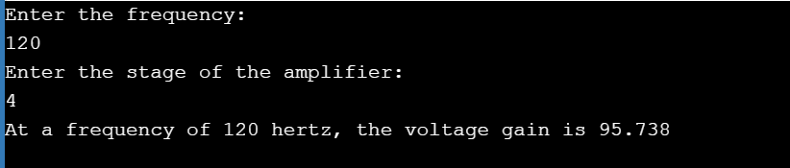

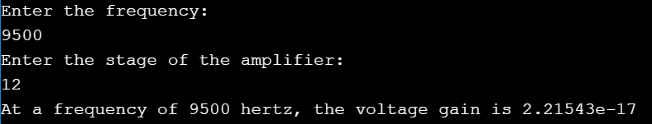

Task 3.8

Program description
This program prompts the user to enter data about a computer, username, employee name and IP. The IP is then stored as 4 different parts and used to calculate the IP in an integer form. The iomanip library is used to display the output in a formatted manner.

Source Code

#include <iostream>
#include <cmath> //calculations
#include <iomanip> // for setwidth function
#include <string> // For getline

/* This program produces a text-based form displaying data about a particular computer. */

using namespace std;

int main()
{
//Variable Declarations
string username, empname , mac, serialno;
char pctype;
double cpuspeed;
unsigned long long int IP = 0; // The integer data type wasn't big enough to store the ip so used long long.
int cores = 0;
unsigned int iP_part_1, iP_part_2, iP_part_3, iP_part_4 = 0;

// User Prompts
cout << " Please Enter The Username: ";
getline(cin, username);
cout << "\n Please Enter The Employee Name: ";
getline(cin, empname);
cout << "\n Please Enter The PC serial number(max 10): ";
cin >> serialno;
cout << "\n Please Enter The PC type (S=Server, D= Dekstop, L=Laptop, T=Tablet, P= Phone) : ";
cin >> pctype;
cout << "\n Please Enter The Number Of Cores: ";
cin >> cores;
cout << "\n Please Enter The CPU Speed (GHz) : ";
cin >> cpuspeed;
cout << "\n Please Enter The MAC Address : ";
cin >> mac;
cout << "\n Please Enter The IPV4 Address Without The Dots (e.g. 111 222 333 444) : "; // Stores ip in different variables
cin >> iP_part_1;
cin >> iP_part_2;
cin >> iP_part_3;
cin >> iP_part_4;

//Calculates IP
IP = iP_part_1 * pow(256., 3) + iP_part_2 * pow(256., 2) + iP_part_3 * 256 + iP_part_4;

//DISPLAY
// First Line
cout << "\n __________" << setw(67)
<< "+ \n";
cout << "| User: "
<< username << "|" << setw(10)
<< "Employee:" << setw(20)
<< empname << "|" << setw(8)
<< "Serial:" << setw(12)
<< serialno << setw(8)
<< "| \n";

// Second Line
cout << " __________" << setw(67)
<< "+ \n";

cout << "| Type: "
<< pctype << "|" << setw(7)
<< "Cores:" << setw(3)
<< cores << " |" << setw(5)
<< "Speed:" << setw(5)
<< cpuspeed << "Ghz "
<< "|" << setw(5)
<< "MAC:" << setw(10)
<< mac << " |" << setw(3)
<< " IP:" << setw(4)
<< iP_part_1 << "." << iP_part_2 << "." << iP_part_3 << "." << iP_part_4 << setw(4)
<< "| \n";

// Second Line
cout << " __________" << setw(67)
<< "+ \n";

// Third Line
cout << "|" << setw(40)
<< "IP Address as integer:" << setw(11)
<< IP << setw(26)
<< "| \n";

cout << setw(78) << "+ \n";

return 0;
}

Screenshots showing working program
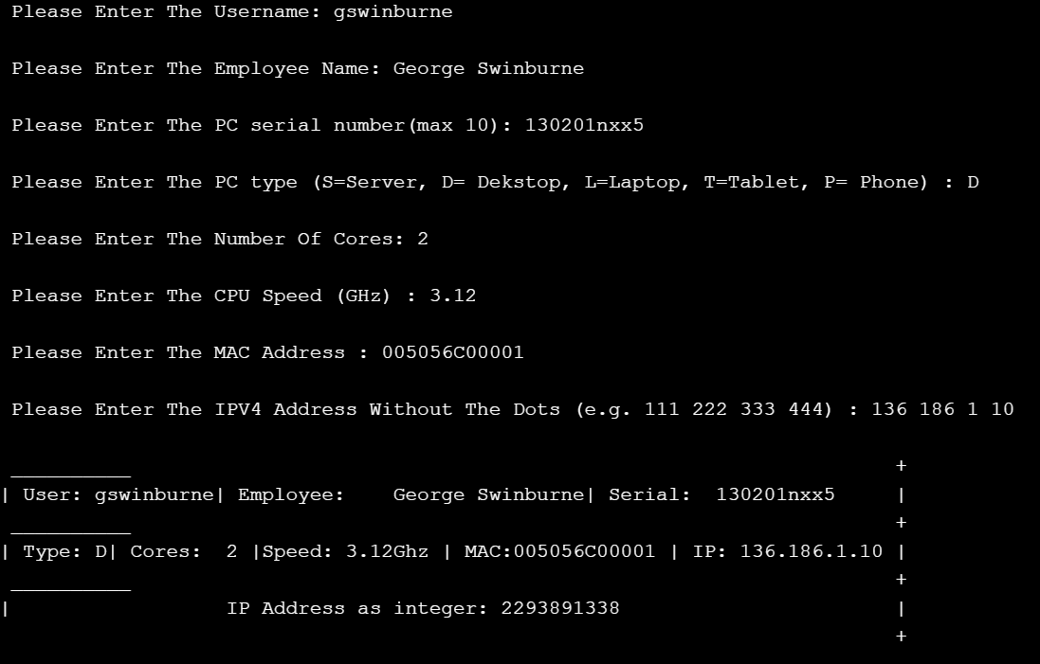

Task 4.9

Program description

This program takes the weekday as a number Sunday being 1 and Saturday 7. (these are taken in an integer and then passed through the switch statement. Then the user is promoted whether it is raining or not. If yes then user enter 1 and 0 for no. If statements are then used to display the output based on the two inputs given by the user.

Source Code
- #include <iostream>

- using namespace std;

- int main()
- {
- // Variable Declarations
- int week;
- int rain;
- do
- {
- cout << "\nEnter week number (1-7):"; // User input for weekday.
- cin >> week;
- switch (week)
- {
- case 1: //Switch statement to display weekday output
- cout << "Sunday";
- break;
- case 2:
- cout << "Monday";
- break;
- case 3:
- cout << "Tuesday";
- break;
- case 4:
- cout << "Wednesday";
- break;
- case 5:
- cout << "Thursday";
- break;
- case 6:
- cout << "Friday";
- break;
- case 7:
- cout << "Saturday";
- break;
- default:
- cout << "\nInvalid Input! Please enter week in between 1-7.";
- }
- } while (week <= 0 || week > 7); // Do while loop for invalid input
- do
- {
- cout << "\nIs it raining today? (1)-Yes OR (0)-No.\n"; //taking 1 for yes and 0 for no
- cin >> rain;
- } while (rain < 0 || rain > 1); // Do while loop for invalid input

- // OUTPUT STATEMENTS
- // If statements to display output

- // IF IT IS RAINING
- if (week == 1 && rain == 1)
- {
- cout << "\nRead in bed";
- }
- if (week == 2 && rain == 1)
- {
- cout << "\nIt is raining today. Take an umbrella with you.";
- }
- if (week == 3 && rain == 1)
- {
- cout << "\nIt is raining today. Take an umbrella with you.";
- }
- if (week == 4 && rain == 1)
- {
- cout << "\nIt is raining today. Take an umbrella with you.";
- }
- if (week == 5 && rain == 1)
- {
- cout << "\nIt is raining today. Take an umbrella with you.";
- }
- if (week == 6 && rain == 1)
- {
- cout << "\nIt is raining today. Take an umbrella with you.";
- }
- if (week == 7 && rain == 1)
- {
- cout << "\nRead in bed";
- }

- // IF IT IS NOT RAINING
- if (week == 1 && rain == 0) //STARTING FROM SUNDAY.
- {
- cout << "\nYou go out and have fun";
- }
- if (week == 2 && rain == 0)
- {
- cout << "\nIts not raining. You won't need a umbrella today";
- }
- if (week == 3 && rain == 0)
- {
- cout << "\nIts not raining. You won't need a umbrella today";
- }
- if (week == 4 && rain == 0)
- {
- cout << "\nIts not raining. You won't need a umbrella today";
- }
- if (week == 5 && rain == 0)
- {
- cout << "\nIts not raining. You won't need a umbrella today";
- }
- if (week == 6 && rain == 0)
- {
- cout << "\nIts not raining. You won't need a umbrella today";
- }
- if (week == 7 && rain == 0)
- {
- cout << "\nYou go out and have fun";
- }

- }

Screenshots showing working program

